Assignment Report

for

Library Management

By Himanshu Deswal

A00258741

Table of Contents

Table of Contents i

1. Introduction 2

2. Screenshots 2

4. Classes and Source Code 6

5. Description 9

6. Conclusion 13

# Introduction

Library management Assignment is intended to implement all the topics which have been covered in the class ,including inheritance, Aggregation, Linklist, Window builder using swing and make sure we have fully understood the concepts which are being taught by our Mentor.

1. Add books
2. Issue Book
3. Return Book
4. Search & View Details
5. Delete Book

# Screenshots

**Start Page:**

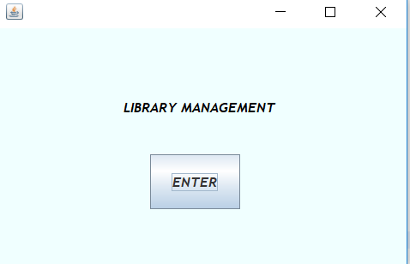

**Login page:**

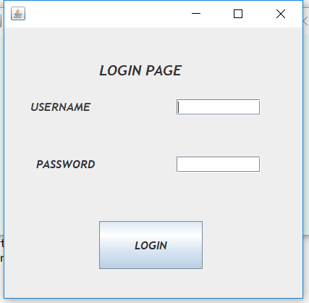

**MyFrame:**

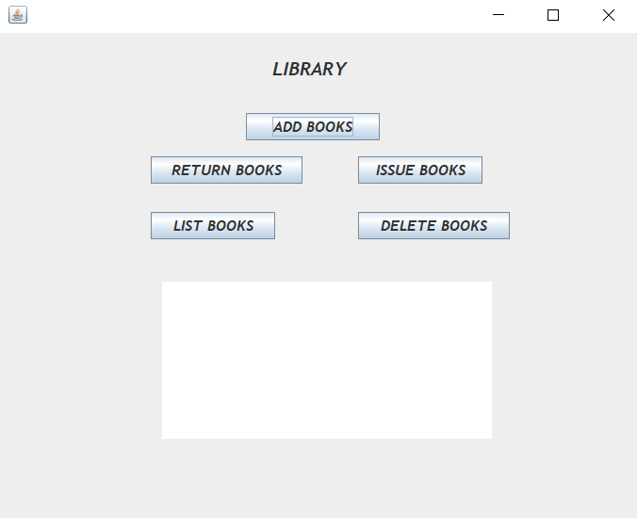

**View Upcoming Books (Output):**

**Add Book to LinkList:**

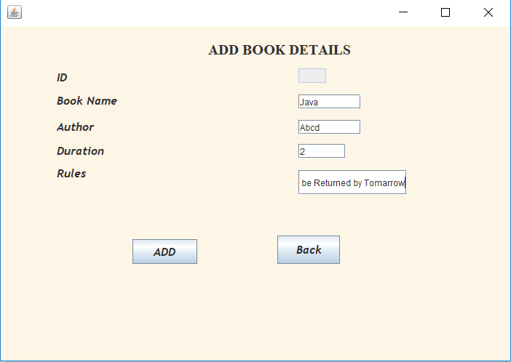

**Search a book:**

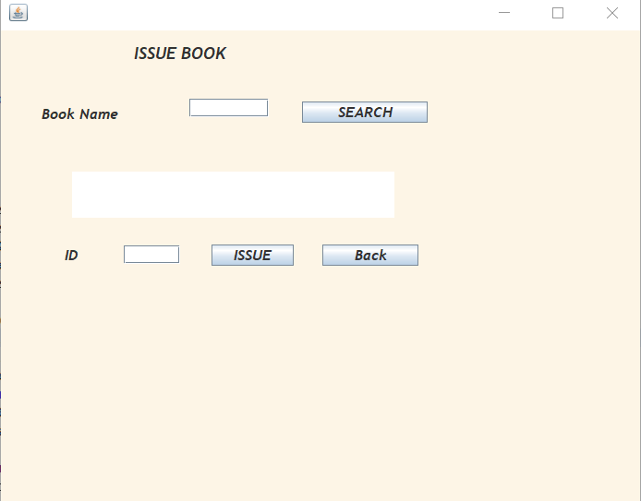

# Classes and Source Code:

1. Implementing Linked List:

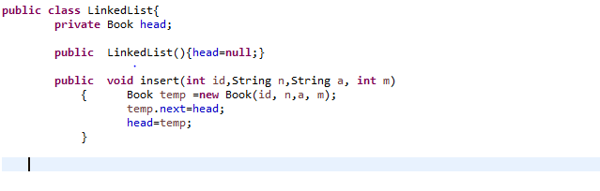

This is the very start of the Linked List code, where I have defined the linked list and created a variable *head* to point at the head of the list. After that is the *insert function* which is very important in a linked list, in this I have passed 4 parameters id, n, a, m. Which denote ID, Name of the Book, Author of the Book, and Price of the Book.

**Implementing Login**

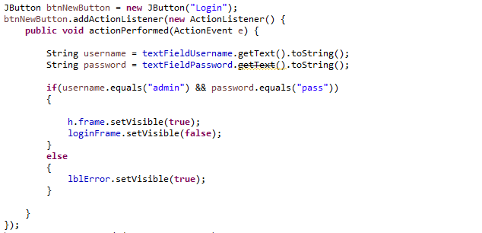

**Adding Book to the List**

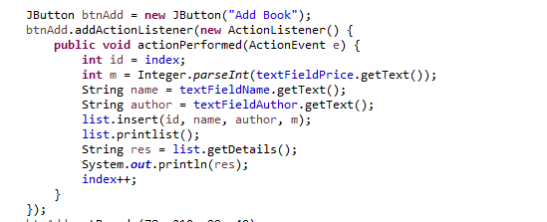

This is used to add the details of the book to the linked list and then print it.

**Searching a book:**

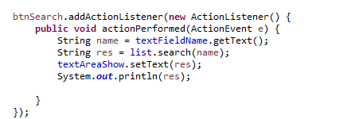

# Problem Description:

I had problem with updating the records with the linked list as liked list can work with bot FIFO and LIFO I took “id” as a primary value to fetch and update the records and linked list was hard to implement.

Also creating a User Interface with window builder helped to get the desired style I needed which helped me in accelerating the assignment progress.

# Conclusion:

The assignment was good and fun to implement I learned a lot about linked list and Window builder which otherwise would not have been made possible. The assignment helped me in gaining the clarity about the aggregation and use of inheritance. I would like to do more assignments like this and as this helped me in polishing my coding knowledge and would help me in my other projects directly or indirectly.